Question: Why do you recommend WordPress for building websites?

Response: WordPress is a versatile and user-friendly platform that powers over 40% of websites globally. It allows clients to easily manage their content, has a vast range of plugins for added functionality, and is highly customizable for any business. Plus, it’s SEO-friendly, making it easier for your website to rank in search engines.

Question: Can you help me purchase a domain and set up hosting?

Response: Yes, I provide full assistance with purchasing a domain name and setting up reliable hosting services. I’ll guide you in selecting the best domain that reflects your brand and ensure the hosting service is secure, fast, and scalable to handle your website's needs as it grows.

--

Question: What type of hosting is best for a WordPress website?

Response: For WordPress sites, I recommend managed WordPress hosting. It offers better performance, security, and automatic updates. Depending on the size of your website and traffic expectations, I’ll help you choose between shared hosting, VPS, or dedicated hosting for optimal performance.

--

Question: How will my website perform in terms of speed and security?

Response: I optimize WordPress websites for both speed and security. I implement caching techniques, optimize images, and use reliable hosting to ensure fast load times. For security, I install SSL certificates, set up firewall protections, and use security plugins to safeguard your site against threats.

--

Question: Will I be able to make updates to my WordPress website on my own?

Response: Absolutely! WordPress is known for its user-friendly interface. I offer training sessions after the project completion to ensure you can easily update text, images, and even add new pages. You’ll have full control of your content without needing coding knowledge.

--

Question: How do you ensure that my WordPress website is optimized for search engines (SEO)?

Response: I integrate SEO best practices from the start. I install and configure essential plugins like Yoast SEO to help optimize your pages, posts, and images. Additionally, I ensure clean coding, proper URL structure, and fast load times, all of which contribute to better search engine rankings.

--

Question: How much does a basic WordPress website cost, and what is included?

Response: A basic WordPress website starts at $500, which includes domain setup, hosting configuration, a custom design, up to 5 pages, SEO optimization, and mobile responsiveness. Additional features like eCommerce, booking systems, or advanced forms can be added based on your needs.

--(Note you can Alter or Reduce the price)

--

Question: Can you migrate my existing website to WordPress?

Response: Yes, I offer migration services to transfer your existing website to WordPress. This process includes backing up your current content, installing WordPress, migrating data, and ensuring everything functions properly on the new platform without any downtime.

--

Question: What post-launch support do you provide for WordPress websites?

Response: After launch, I provide ongoing support to ensure your website runs smoothly. This includes regular updates, backups, performance checks, and security monitoring. If you ever need additional features or adjustments, I’m always available to assist with future changes.

--

Question: How do you ensure that my WordPress website meets my business goals?

Response: I start by understanding your business objectives, target audience, and key needs. From there, I design the website to not only look professional but also align with your conversion goals, whether that’s generating leads, increasing sales, or boosting brand visibility. Every feature, from calls to action to user experience, is optimized for success.

--

Question: Will my WordPress website be mobile-friendly?

Response: Yes, mobile responsiveness is a standard part of my web design process. I ensure that your WordPress website looks great and functions perfectly across all devices—whether on desktops, tablets, or smartphones—so that your visitors have a smooth experience no matter how they access your site.

--

Question: Can you help me set up my hosting account?

Response: Yes, I provide full support in setting up your hosting account. I’ll walk you through the process of choosing the best hosting provider, configuring the hosting settings, and ensuring your WordPress website is properly linked to your domain. I make sure everything is secure and optimized for performance.

--

Question: What information do I need to provide to start my website project?

Response: To get started, I’ll need some basic information from you, such as your business name, logo, branding guidelines, any content (text, images) you want to use, and details about your products or services. If you don’t have everything ready, I can help guide you through creating the necessary materials.

--

Question: Do I need to have a domain and hosting before starting the project?

Response: If you don’t already have a domain or hosting, don’t worry! I can help you with selecting and purchasing both. We’ll set this up before we begin the website design to ensure everything is ready when we launch your site.

--

Question: How can I prepare content for my website?

Response: Start by organizing information about your business, services or products, and any images or videos you’d like to include. If you need help, I offer content writing and professional photography services to ensure your website has high-quality content that resonates with your audience.

--

Question: What payment options do you offer for starting a website project?

Response: I offer flexible payment plans depending on the scope of the project. Typically, a deposit is required to start, with the remainder due upon completion. We can discuss a payment structure that works for you during our initial consultation.

--

Question: How do I get updates on the progress of my website project?

Response: I provide regular updates throughout the project via email or scheduled calls. You’ll be involved in key milestones such as design approval and functionality testing, so you can see how the website is evolving. Open communication is a priority to ensure the project stays on track.

--

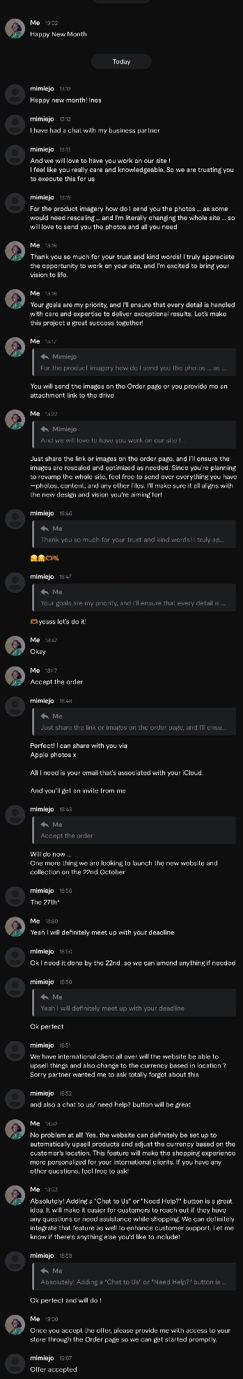

Anoter